**Analysis Conclusions**

The final KNIME workflow is shown below:

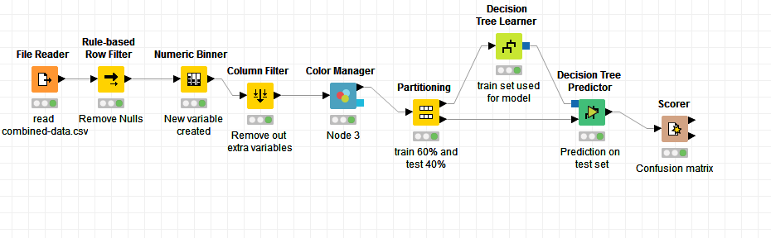

What makes a HighRoller vs. a PennyPincher?

According to the decision tree, the platform used to play this game is the main independent variable which affects our depending variable. Thus a user using **iphone** has greater chances of being a high roller.

|  |
| --- |
| **Specific Recommendations to Increase Revenue** |
| 1. Users who tend to spend more should be given more opportunities to spend i.e. more in app purchases for them in comparison to pennypinchers. |
| 2. As more people advance towards a higher level its in app purchases can be made more expensive but only when a lot of people reach that level. |